Product Overview
YW non-clogging submerged sewage pump is a new generation of pump products developed by Hunan Lijia Machinery in combination with the use characteristics of domestic pumps. It has the characteristics of remarkable energy saving, winding prevention, non-clogging, automatic installation and automatic control. It has unique effect in discharging solid particles and long fibre garbage.
YW non-clogging submerged sewage pump adopts unique impeller structure and new mechanical seal, which can effectively transport solid and long fibers. Compared with the traditional impeller, the impeller of the pump adopts single channel or double channel. It is similar to a bend pipe with the same cross-section size. It has very good flowability. With a reasonable worm chamber, the pump has high efficiency, the impeller is tested by dynamic and static balance, and the pump has no vibration in operation.

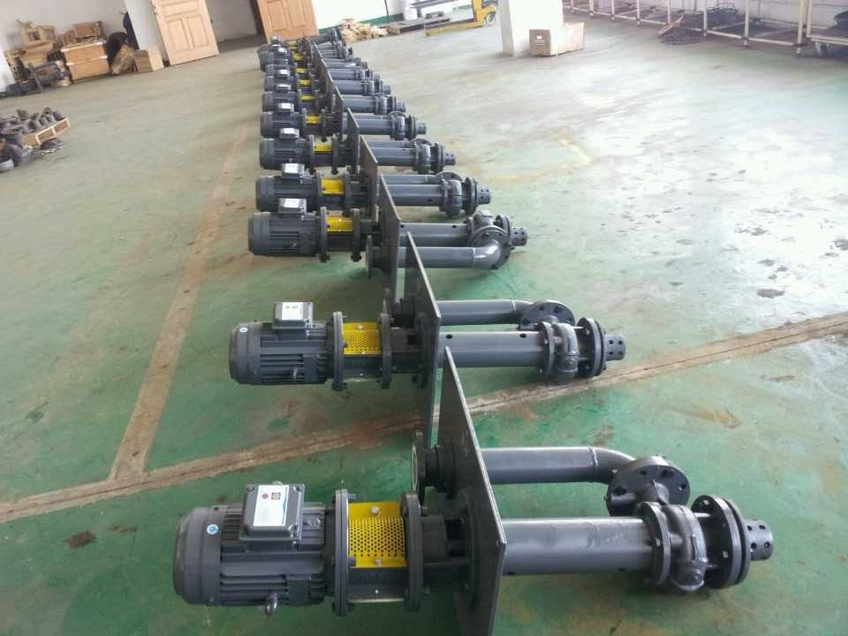
Main Application of YW Non-clogging Underwater Sewage Pump
Applicable to chemical, petroleum, pharmaceutical, mining, paper industry, cement plant, steelmaking plant, power plant, coal processing industry, as well as urban sewage treatment plant drainage system, municipal engineering, construction site and other industries conveyor belt particles of sewage, sewage, sewage, sewage, sewage, sewage, also used for pumping clean water and corrosive media.

Model Significance of YW Type Unblocked Underwater Sewage Pump
Example: 100YW 15-10-1.1
100-pump discharge caliber is 100mm
YW-Hydraulic Sewage Pump
15-Design Point Flow Rate 1553/h
10-Design Point Lift is 10m
1.1-motor power is 1.1Kw
Performance Range (Design Point)
Flow: 10-900m3/h,Head: 5-45m

Structural characteristics of YW non-blocking submerged sewage pump

1. The unique large passage impeller structure is adopted, which greatly improves the trafficability of sewage and effectively passes through solid particles with diameter of about 20%~30% of the diameter of the pump.
2. The unit is vertical under-water structure, and different under-water installation depth can be adopted according to user's needs.
3. The balanced rotor and reasonable bearing arrangement can effectively balance the radial and axial loads of the pump, thus ensuring the long-term stable operation of the unit with low vibration and noise.
4. Mechanical seals are made of new hard and corrosion-resistant tungsten carbide materials. Meanwhile, the seals are improved to double-end seals, so that they can run in oil chamber for a long time, and the pumps can run safely and continuously for more than 8000 hours.
5. It can be equipped with liquid level automatic control cabinet according to user's needs. It can automatically control the start and stop of the unit according to the change of liquid level. It does not need special person to take care of it. It is very convenient to use and easy to realize automatic management.
6. Pump and motor are connected by elastic coupling. From the motor end, the pump rotates clockwise.

Product Structure
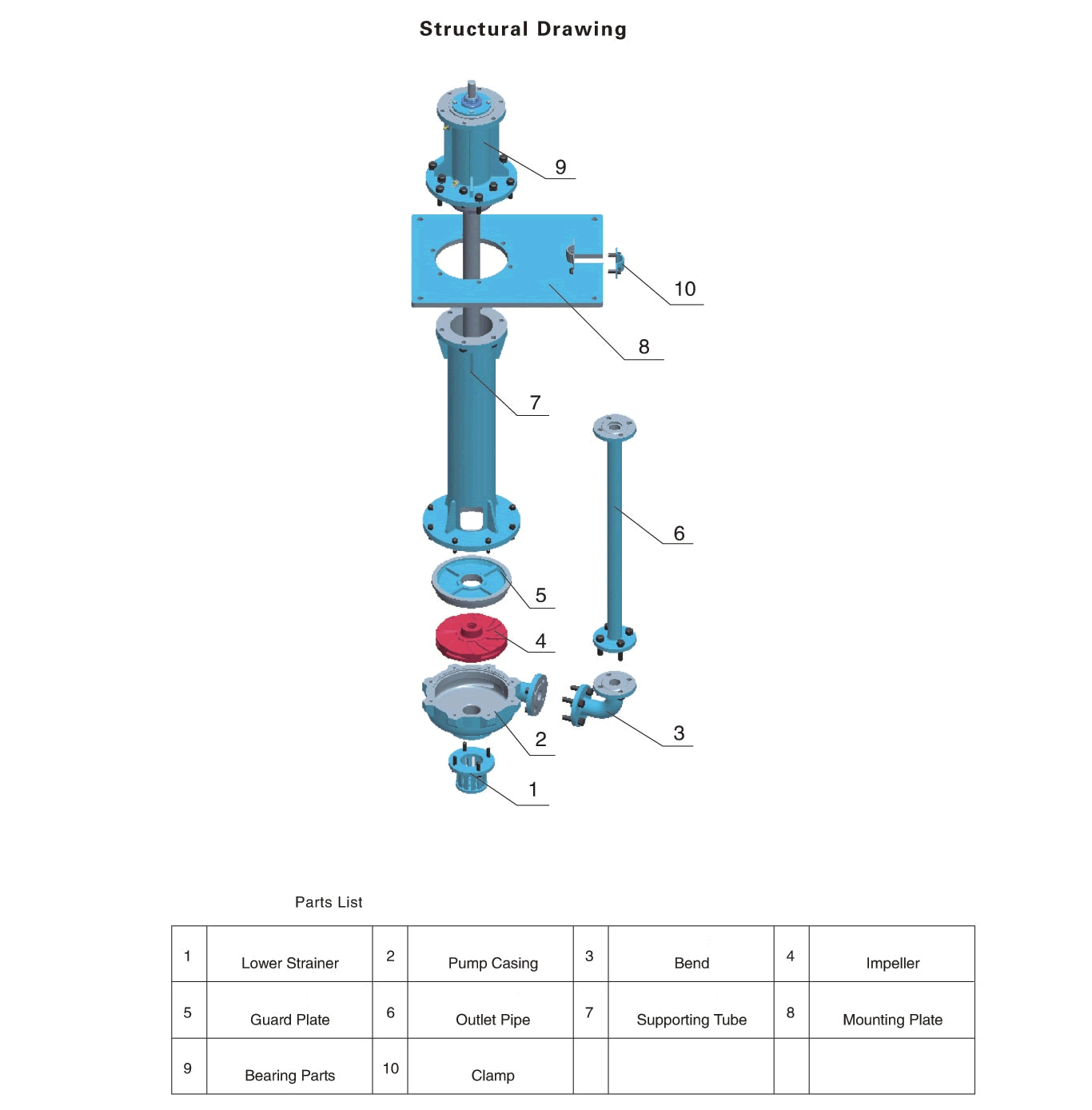
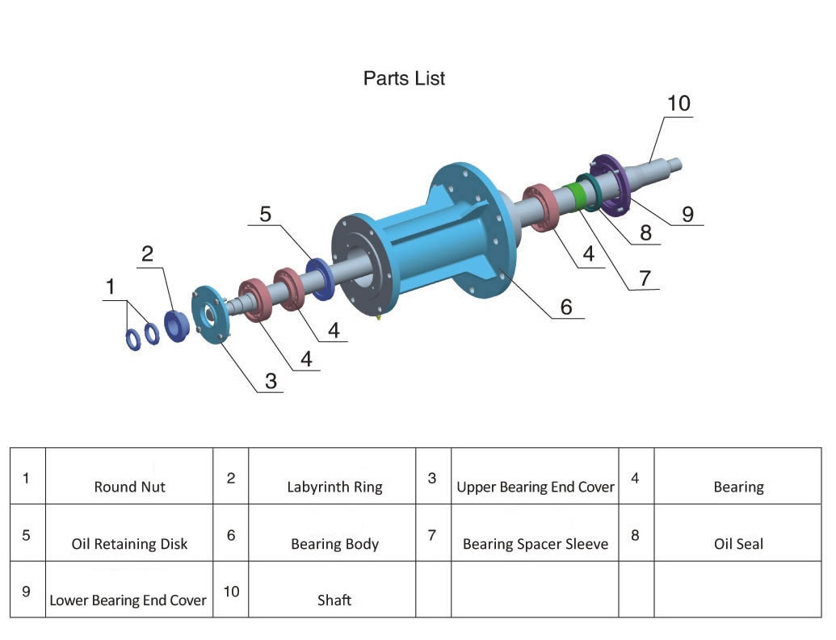
Troubleshooting of RV-SP Vertical Leachate Slurry Pump

fault | Reason | Solve
Unable to start and run | 1. The feeder is open.  2. The voltage is too low.  3. There is no axial clearance between the two half couplings and they are stuck.  4. The impeller is stuck by debris.  5. The impeller is close to the volute.  6. Dropping of nuts and damage of flat keys make impeller slippery.  7. The flat key of the coupling is damaged. | 1. Check fuses and wiring and replace them.  2. Turn up the voltage or use it when the voltage rises.  3. Adjust the axial clearance between the two half couplings to 1-1.5 mm.  4. Exclude impurities.  5. Re-assembling, separating impeller and volute.  6. Install flat keys and nuts.  7. Change flat keys.
Overload | 1. Improper assembly of each part of the pump makes it difficult to rotate and foreign body is stuck.  2. Concentric bottom change, bearing damage, shaft deformation.  3. Reverse rotation.  4. The head is too low and the flow is too large. | 1. Re-assembly and removal of foreign bodies.  2. Correct parts and replace bearings.  3. Change the direction of the motor.  4. Avoid prolonged use as far as possible.
Insufficient flow | 1. The suction port is blocked and the pit is not deep enough for the pump to suck the medium.  2. The mud pipeline is blocked.  3. Motor speed is lower than rated speed.  4. Impeller damaged.  5. The lift is too high and the transportation is too far.  6. Reverse rotation.  7. Large leakage.  8. The impeller is surrounded by debris.  9. The medium is too thick or the supply is not enough. | 1. Remove the suction obstruction and move the pump so that the volute is completely embedded in the medium water.  2. Check the pipeline and remove the obstruction.  3. Increase the motor speed.  4. Change impeller.  5. Reduce lift and shorten conveying distance.  6. Change the direction of the motor.  7. Check the cause of leakage and replace the parts that cause leakage.  8. Exclude impurities.  9. Dilute the medium and increase the supply.
Noise and vibration | 1. Friction between impeller and volute.  2. The bearing has been damaged or less oil.  3. The pump shaft is not concentric with the motor, and the shaft is bent.  4. The nut is loose.  5. There are impurities in the volute.  6. There are hard substances in the working fluid.  7. There is air infiltration in the suction.  8. The temperature of pumping liquid is too high. | 1. Check the assembly of the pump and adjust it.  2. Replacement of bearings or refueling.  3. Adjust concentricity and correct axis.  4. Tighten the nut.  5. Exclude impurities.  6. Control the size of impurities in the intake pump and encrypt the filter.  7. Deep-buried volute.  8. Reduce the liquid temperature.

Parts catalogue

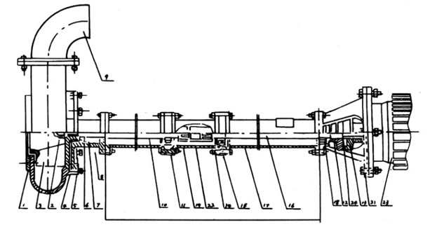

NO | Type/Part Name | RV-SP
NO | Type/Part Name | Number | quantity | Remarks
1 | Net cover | 1 | 1
2 | Impeller nut | 2 | 1
3 | Impeller | 3 | 1
4 | Pump case | 4 | 1
5 | Pump seat | 5 | 1
6 | o-ring | 6 | 1 | Modified mechanical seal
7 | oil seal | 7 | 4 | Modified mechanical seal
8 | Axle sleeve | 8 | 1 | Modified mechanical seal
9 | Outflow elbow | 9 | 1
10 | Pump shaft | 10 | 1
11 | Bearing | 11 | 2
12 | Driven coupling | 12 | 1
13 | Active Coupling | 13 | 1
14 | Connector | 14 | 1
15 | Bearing seat | 15 | 2
16 | Coupling shaft | 16 | 1
17 | Support barrel | 17 | 2
18 | Bearing cap | 18 | 1
19 | Driven coupling | 19 | 1
20 | Motor base | 20 | 1 | Fixed plate
21 | Motor seat C | 21 | 1
22 | Active Coupling | 22 | 1
23 | Motor | 23 | 1
24 | Elastic block | 24 | 1
☆
Installation Diagram of RV-SP Vertical Leachate Slurry Pump
